WEEK 4 FINAL ASSESSMENT REPORT

Comprehensive Data Analysis, Visualization and Predictive Modeling

India Air Quality Dataset — 2020 to October 2025

Submitted by | Priyadarsine G.N.
Programme | M.Sc. Data Science
Tool | R / RStudio
Dataset | India Air Quality Dataset
Observations | 378,328
Study Period | 1 January 2020 – 31 October 2025

Executive Summary
This final report consolidates the four-week data analysis workflow performed on an India Air Quality dataset covering 1 January 2020 to 31 October 2025. The project progressed from data cleaning and preliminary analysis in Week 1, through visualization and insight communication in Week 2, to statistical analysis and predictive modeling in Week 3. Week 4 integrates these outputs into one coherent analytical narrative.
The dataset contains 378,328 observations and six original variables: Date, S.No, City, Air.Quality, AQI.Value and Prominent.Pollutant. The cleaning process identified no missing values and no exact duplicate rows. Date was converted to a proper date type, while Year and Month were derived for temporal analysis. AQI values ranged from 3 to 500, with a mean of 109.55 and median of 88.
The visual analysis showed a right-skewed AQI distribution, differences among air-quality categories, seasonal variation across months, changes in average AQI across years, and substantial differences among cities. The average AQI increased from 113.75 in 2020 to 121.92 in 2022 and then decreased to 87.66 in 2025 through October. For statistical analysis, the Shapiro-Wilk test indicated non-normality, while one-way ANOVA found statistically significant differences in average AQI across months. A baseline linear regression using Year and Month achieved a test MAE of 47.426, RMSE of 64.395 and R² of 0.239. The model was stable across five-fold cross-validation but had limited predictive power, highlighting the importance of additional explanatory variables.

Introduction
Air quality is an important environmental and public-information issue. AQI provides a convenient numerical measure for communicating the overall level of air pollution. The objective of this project was not only to inspect AQI values, but to demonstrate a complete data-analysis workflow in R: preparing raw data, exploring patterns, communicating insights visually, testing statistical hypotheses, and developing a transparent baseline predictive model.
The same dataset was retained throughout the four weeks. This provided continuity between cleaning, visualization, statistical testing and modeling and reduced unnecessary changes to the analytical foundation.

Dataset Overview
Variable | Type / Role | Description
Date | Date | Observation date
S.No | Categorical | Month label present in the source data
City | Categorical | Indian city
Air.Quality | Categorical | Air-quality category
AQI.Value | Numerical | AQI measurement used for  analysis and prediction
Prominent.Pollutant | Categorical | Prominent pollutant field in the source dataset
The dataset contains 304 unique cities, 2,130 unique dates and six air-quality categories. The Prominent.Pollutant field contained one unique value in the supplied dataset, so it was not useful as a differentiating analytical predictor.

Overall Methodology
- Week 1 — Data cleaning and preliminary analysis: loaded the CSV, inspected structure, checked missing values and duplicates, converted Date, derived Month, examined AQI outliers and produced descriptive statistics.
- Week 2 — Data visualization: created a histogram, category bar chart, year-wise line chart, monthly boxplot and top-city bar chart using ggplot2.
- Week 3 — Statistical analysis and predictive modeling: performed correlation and normality analysis, one-way ANOVA, linear regression, 80/20 train-test evaluation, five-fold cross-validation and diagnostic analysis.
- Week 4 — Integration: consolidated the previous work into a single narrative, connected findings across stages, discussed limitations and proposed future directions.

Data Preparation and Cleaning
The raw CSV was imported into R. Initial inspection showed 378,328 rows and six columns. No missing values were found in the original variables. No exact duplicate rows were identified. The AQI variable was numeric and ranged from 3 to 500, so no invalid negative values or values above 500 were present.
aqi <- read.csv( "AQI_2020_to_2025_October.csv", stringsAsFactors = FALSE
)

colSums(is.na(aqi)) sum(duplicated(aqi))

aqi$Date <- as.Date( aqi$Date,
format = "%d-%m-%Y"
)

aqi$Month <- format(aqi$Date, "%B")
aqi$Year <- as.numeric(format(aqi$Date, "%Y"))
An IQR-based outlier analysis gave Q1 = 56, Q3 = 140 and IQR = 84. The upper IQR boundary was 266, resulting in 19,567 observations (5.17%) above that statistical threshold. These observations were retained rather than deleted because high AQI values can represent genuine pollution events rather than data-entry errors. The maximum observed AQI was 500.
For exploratory modeling work, AQI was also standardized using a z-score transformation. The resulting standardized variable had a mean approximately equal to zero and standard deviation equal to one.
Categorical variables were represented as factors where required for statistical modeling.

Preliminary Statistical Findings
Statistic | AQI.Value
Mean | 109.548
Median | 88.000
Standard deviation | 74.007
Minimum | 3
Maximum | 500
The mean being higher than the median indicates a right-skewed distribution. The AQI distribution also contains a substantial upper tail, consistent with the observed high-AQI values.

Air-quality category distribution:

Category | Count | Percentage
Good | 74,986 | 19.82%
Moderate | 114,209 | 30.19%
Poor | 33,894 | 8.96%
Satisfactory | 143,820 | 38.01%
Severe | 1,176 | 0.31%
Very Poor | 10,243 | 2.71%

Visualization and Insight Communication
Five visualizations were developed in Week 2 using ggplot2. Each visualization was selected to communicate a different aspect of the dataset.

Distribution of AQI Values
The histogram showed a strongly right-skewed distribution, with many observations concentrated at relatively lower AQI values and a long upper tail.

Distribution of Air Quality Categories
The category bar chart showed that Satisfactory and Moderate observations were the most frequent, while Severe observations were comparatively rare.

Average AQI by Year
Average AQI was 113.75 in 2020, 120.77 in 2021, 121.92 in 2022, 115.09 in 2023, 105.69 in 2024 and 87.66
in 2025 through October.

Monthly Variation in AQI
The boxplot showed clear seasonal differences. January, November and December had higher central AQI values, while July–September showed lower central values, with many high-value observations remaining as outliers.

Top 10 Cities by Average AQI
The city comparison highlighted substantial geographic variation, with Greater_Noida, Byrnihat, Darbhanga and Delhi among the highest average-AQI entries in the analysis.

Statistical Analysis and Hypothesis Testing

Correlation
The Pearson correlation between Year and AQI.Value was -0.1257. This is a weak negative linear relationship, meaning that the year alone has limited linear association with AQI in the full dataset.

Normality
A Shapiro-Wilk test on a random sample of 5,000 AQI values gave W = 0.85957 and p < 2.2 × 10^-16. The null hypothesis of normality was rejected. The result is consistent with the right-skewed histogram.

One-Way ANOVA
The hypothesis test examined whether mean AQI differs across months.

    - H₀: Mean AQI is the same across all months.
    - H₁: At least one month has a different mean AQI.
The ANOVA returned F ≈ 10,222 with p < 2 × 10^-16. Therefore, H₀ was rejected at the 5% significance level. There is strong statistical evidence that average AQI differs by month.

Predictive Modeling
A baseline linear regression was developed with AQI.Value as the target and Year plus Month as predictors. Air.Quality was intentionally excluded because it is an AQI category derived from the AQI measurement; using it to predict AQI would introduce data leakage.
An 80/20 random train-test split produced 302,662 training observations and 75,666 test observations. The regression model was evaluated on the held-out test set and then checked with five-fold cross-validation.
lm_model <- lm(
AQI.Value ~ Year + Month, data = train_data
)

test_predictions <- predict( lm_model,
newdata = test_data
)

Metric | Result
Test MAE | 47.426
Test RMSE | 64.395
Test R² | 0.239
Average CV MAE | 47.695
Average CV RMSE | 64.690
Average CV R² | 0.237
The test R² of 0.239 means that the baseline model explains approximately 23.9% of the variation in unseen AQI observations. The average absolute error was about 47.4 AQI points. The five-fold cross-validation results were close to the test results, indicating reasonably stable performance but limited predictive power.

Model Diagnostics
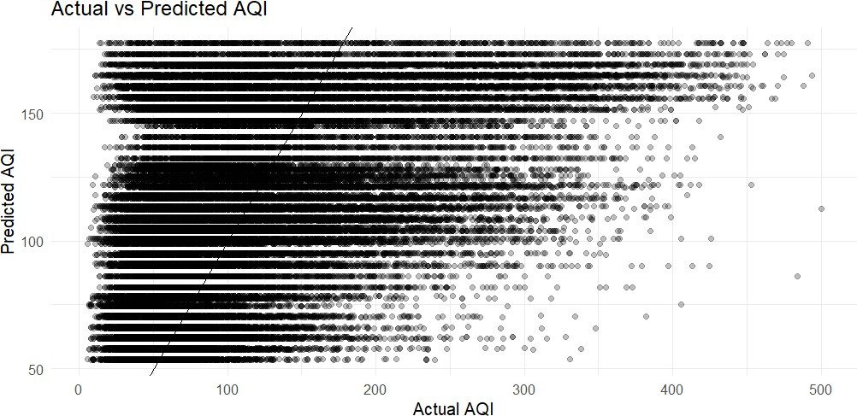

Figure 1: Actual vs Predicted AQI

The actual-versus-predicted plot shows substantial scatter around the ideal reference line. The model captures broad patterns but does not predict many high-AQI observations closely.
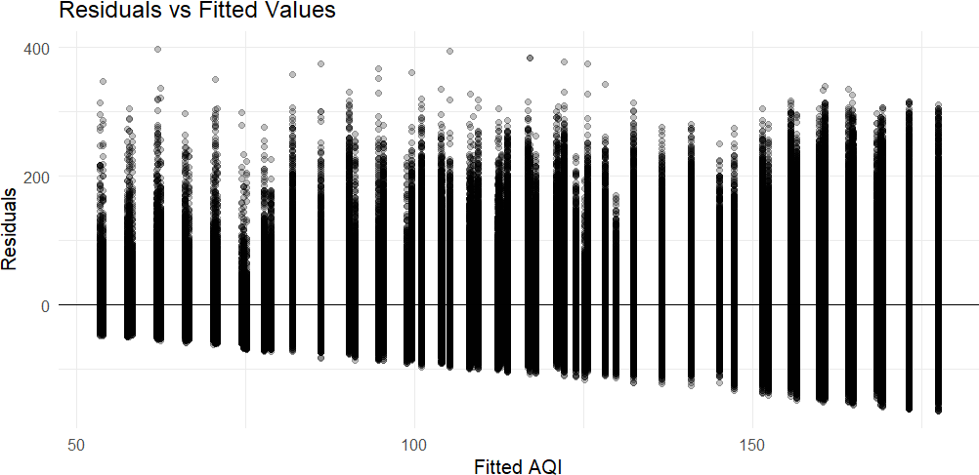

Figure 2: Residuals vs Fitted Values

The residual plot shows a structured pattern and changing spread around zero. This indicates that the simple Year + Month specification does not capture all factors influencing AQI and that model assumptions are not fully satisfied.

Integrated Discussion and Impact
Taken together, the analysis demonstrates that AQI is influenced by temporal and geographic variation. The visualization results show clear differences by month, year and city, while the ANOVA confirms that monthly differences are statistically significant. The decline in average AQI from 2022 to 2025 in the available dataset is an important descriptive pattern, although it should not be interpreted as a causal claim because the dataset ends in October 2025 and the analysis does not control for meteorological, policy or measurement factors.
From a practical perspective, this type of analysis can help analysts communicate pollution patterns, identify periods requiring closer monitoring, compare locations, and establish a baseline for future forecasting work. The relatively weak predictive performance also provides a useful analytical lesson: time variables alone are insufficient to explain all AQI variation.

Challenges Encountered
- The dataset was large, with 378,328 observations, requiring careful handling and simple, efficient R operations.
- The source data contained a month field that duplicated information available from Date, so Date was used as the reliable basis for deriving Month and Year.
- The AQI distribution was non-normal and strongly right-skewed, making the distributional assumptions of simple statistical models less ideal.
- IQR-based outlier detection identified 19,567 observations above the statistical upper boundary. These were retained because they can represent genuine severe-pollution events.
- The baseline regression had limited predictive power, which required interpretation of model limitations rather than presenting the model as highly accurate.

Recommendations and Future Directions
- Add city-level predictors to capture geographic differences in AQI.
- Use pollutant concentration variables such as PM2.5, PM10, NO2, SO2 and other available measurements when present in a richer dataset.
- Add meteorological variables such as temperature, humidity, wind speed and rainfall.
- Compare linear regression with tree-based methods such as Random Forest or Gradient Boosting.
- For future forecasting, use time-aware train/test validation instead of random splitting.
- Investigate transformations or robust/nonlinear methods to address skewness and residual heteroscedasticity.
- Extend the dataset beyond October 2025 when reliable data becomes available.

Conclusion
The four-week project completed a full practical data-analysis workflow using R. The work began with data cleaning and preliminary analysis, continued with visual exploration, and progressed to statistical hypothesis testing and predictive modeling. The dataset contained 378,328 observations with no missing values or exact duplicate rows. AQI showed substantial variation, a right-skewed distribution and clear differences across months and cities.
The statistical analysis confirmed significant monthly differences in average AQI. The baseline regression model using Year and Month achieved test MAE 47.426, RMSE 64.395 and R² 0.239, with similar five-fold cross-validation results. Therefore, the model is useful as a transparent baseline but should not be treated as

a high-accuracy predictive system. The most important lesson is that good data analysis combines cleaning, visual evidence, statistical significance, predictive evaluation and honest interpretation of limitations.

Key R Code Used Across the Project
# DATA LOADING
aqi <- read.csv( "C:/Users/PRIYA/OneDrive/Desktop/YuvaIntern_AQI_Analysis/AQI_2020_to_2025_October.csv", stringsAsFactors = FALSE
)

# CLEANING / TRANSFORMATION
aqi$Date <- as.Date(aqi$Date, format = "%d-%m-%Y")
aqi$Month <- factor(format(aqi$Date, "%B"), levels = month.name) aqi$Year <- as.numeric(format(aqi$Date, "%Y"))

# BASIC CHECKS
dim(aqi) names(aqi) str(aqi) summary(aqi)
colSums(is.na(aqi)) sum(duplicated(aqi))

# DESCRIPTIVE STATISTICS
mean(aqi$AQI.Value) median(aqi$AQI.Value) sd(aqi$AQI.Value) range(aqi$AQI.Value)

# OUTLIERS
Q1 <- quantile(aqi$AQI.Value, 0.25) Q3 <- quantile(aqi$AQI.Value, 0.75)
IQR_AQI <- Q3 - Q1
upper_bound <- Q3 + 1.5 * IQR_AQI

# VISUALIZATION
library(ggplot2)

ggplot(aqi, aes(x = AQI.Value)) + geom_histogram(bins = 50) + theme_minimal()

ggplot(aqi, aes(x = Month, y = AQI.Value)) + geom_boxplot() +
theme_minimal()

# STATISTICS
cor(aqi$Year, aqi$AQI.Value, method = "pearson")

set.seed(123)
aqi_sample <- sample(aqi$AQI.Value, 5000) shapiro.test(aqi_sample)

anova_model <- aov(AQI.Value ~ Month, data = aqi) summary(anova_model)

# MODEL
model_data <- na.omit(aqi[, c("AQI.Value","Year","Month")])

set.seed(123)

train_index <- sample( 1:nrow(model_data),
size = 0.80 * nrow(model_data)
)

train_data <- model_data[train_index,] test_data <- model_data[-train_index,]

lm_model <- lm(
AQI.Value ~ Year + Month, data = train_data
)

predicted <- predict( lm_model,
newdata = test_data
)

actual <- test_data$AQI.Value

MAE <- mean(abs(actual - predicted))
RMSE <- sqrt(mean((actual - predicted)^2))

R_squared <- 1 -
sum((actual - predicted)^2) / sum((actual - mean(actual))^2)

